**TITLE: LAPTOP PRICE PREDICTION**

K. SAI SRINIVAS 1 , srinivaskatreddi369@gmail.com 1, Swarnandhra College of Engineering &Technology.

K. TARUN SAI 2, kadalitarunsai1302@gmail.com 2, Swarnandhra College of Engineering & Technology.

K. M.S.SRIRAM 3, kondaveetimohan2003@gmail.com 3, Swarnandhra College of Engineering & Technology.

**ABSTRACT:**

Laptops are now became a most essential and mostly used gadgets around the world . It is widely used by the students , Employees and other working professionals. Considering the present technical advancements, the electronic gadgets like mobiles and laptops are getting costly and many more companies and models are evolving day by day. So it became difficult for the customers and also the sellers in the aspect of pricing.

To overcome this type of difficulties, we are building a model to predict the price of laptops based on the specifications they are made off. The price of the laptop is predicted by taking some input values from the user which were the specifications of the laptop such as Company, Model name, Category, screen type, screen resolution, CPU, RAM, Storage, GPU, Operating System, Operating system Version and Weight.

This laptop price prediction model is developed by using machine learning techniques. Leveraging historical pricing data, features and market trends are incorporated to train the model. The goal is to create an accurate system capable of forecasting laptop prices and helping the customers in making informed purchase decisions. It also aims to investigate the impact of external factors like technical advancements, economic conditions and consumer preferences on laptop prices.

To build this model, various machine learning algorithms such as linear regression, decision trees, and ensemble methods will be explored to identify the most suitable model for predicting laptop prices. Time-series analysis may be incorporated to capture temporal patterns in pricing fluctuations. The anticipated outcome is a well-tuned machine learning model capable of accurately predicting the laptop prices, offering a valuable tool for both the customers and retailers in understanding the pricing dynamics of the laptop market.

This model helps the customers to find the price of the laptop they are looking for according to their required specifications and also to the retailers to fix the price of the laptop according to the market trends and other aspects.

**Keywords**: Linear regression, Decision trees, ensemble methods, Time-series analysis, Machine learning.

**INTRODUCTION:**

Laptop price prediction is a challenging task that requires expert knowledge. The price of a laptop depends on various factors such as brand, model, RAM, ROM, GPU, CPU, etc. In India, the demand for laptops increased significantly highest in five years. This paper suggests that a laptop price prediction system was developed using the supervised machine learning techniques like Random Forest , Decision Tree. The system achieved 84% to 88% prediction precision by using factors like Laptop’s model, RAM, ROM (HDD/SSD), GPU, CPU, IPS Display, and Touch Screen. However, the accuracy of the prediction model depends on the quality of the data used to train the model.

It is important to note that the price of laptops is subject to change due to various factors such as supply and demand, inflation, and currency exchange rates. Therefore, it is difficult to predict the exact price of a laptop in the future. However, you can use the current market trends and expert opinions to make an informed decision when purchasing a laptop.

In conclusion, predicting the price of a laptop is a complex task that involves many factors. This Analysis suggests that a laptop price prediction system was developed using the supervised machine learning technique. The system achieved 84% to 88% prediction precision by using factors like Laptop’s model, RAM, ROM (HDD/SSD), GPU, CPU, IPS Display, and Touch Screen . However, the accuracy of the prediction model depends on the quality of the data used to train the model. Therefore, it is important to use the current market trends and expert opinions to make an informed decision when purchasing a laptop. By doing so, you can ensure that you get the best value for your money and avoid overpaying for a laptop that does not meet your needs.

**Literature Survey:**

[1] Applying rigorous analysis to aid investment decisions is gaining momentum in the United States and the United Kingdom, say Aminah Md Yusof and Ismail Syuhaida. But In Malaysia, the response from local academics was very slow, and for doctors even slower. This article explains how multiple regression analysis (MRA) and its extension hedonic regression analysis can be used to explain price changes of selected houses in Malaysia. Theoretically, every attribute defined as a value judgment is a value, and the harmony of each attribute is specified. This article shows that statistical analysis can analyze real estate investment by taking into account various decisions. More rigorous consideration of various factors can lead to better investment decisions.

[2]

[3] Machine learning (ML) can provide great help in making decisions and predictions based on the amount of facts generated. We also looked at machine learning techniques used in recent developments in the Internet of Things (IoT). Many studies have provided insight into the use of machine learning techniques to predict laptop-only prices. As demonstrated in this article, we present a new method that improves the prediction of desktop usage to better understand the context of avoiding analysis. process.The truth about laptop prices. This prediction model is used by a unique combination of features and learning models from various popular computer programs. We use special computer programs to learn about models such as decision trees, multilayer networks, KNN, and random forests to test which design model is more accurate in predicting laptop speed.

[4]

**METHODOLOGY:**

This study aims to create a regression algorithm model using the Google Collaboratory tool and Jupyter Notebook. The steps of the modeling process are shown in Figure . The first step is to obtain the datasets from the Kaggle website; Then, the data is pre-processed, which involves Data Cleaning and Feature Engineering; Next, the Exploratory Data Analysis (EDA) is performed; To apply machine learning with the Decision Tree and Random Forest algorithms for some sample data is required. The table below shows some data about different laptops and their prices based on their specifications. The data is sourced from Kaggle.com

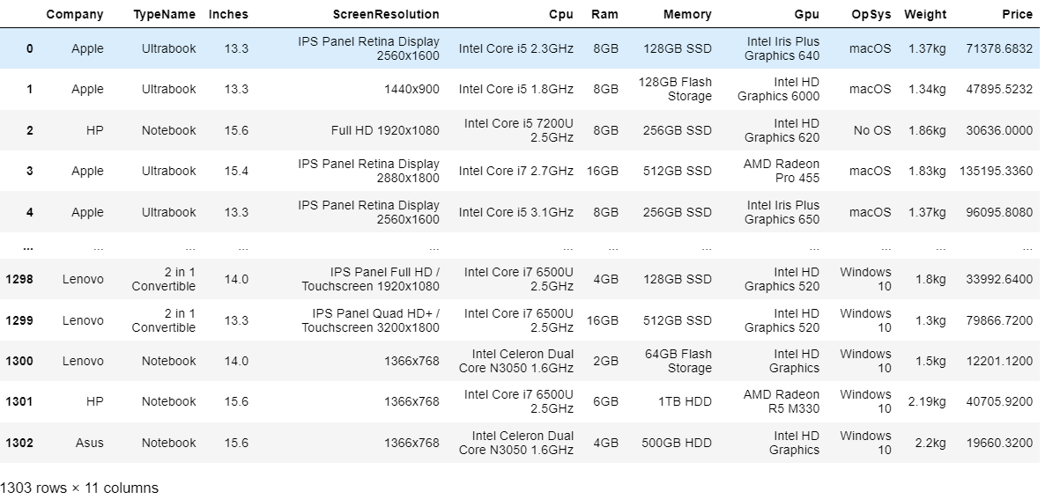

**Fig1.** Dataset

This data is cleaned and explorated using machine learning techniques and that mostly suitable for Decision tree and Random forest algorithms .

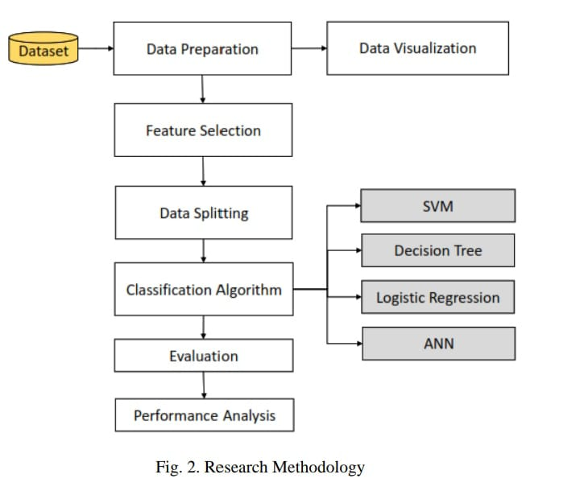

**Fig2.** The representation of data flow.

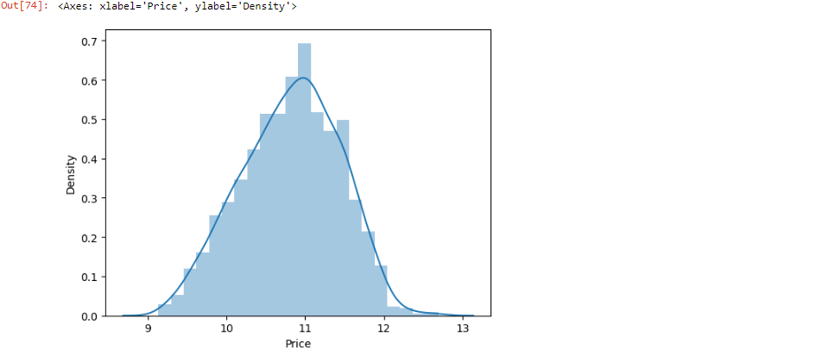

**Fig3.**Density Plot regarding Price for fig1 dataset

Random Forest algorithm can be applied on the the dataset for the classification(To get the optimal price from the dataset). By using the random forest algorithm works 88% accurately.

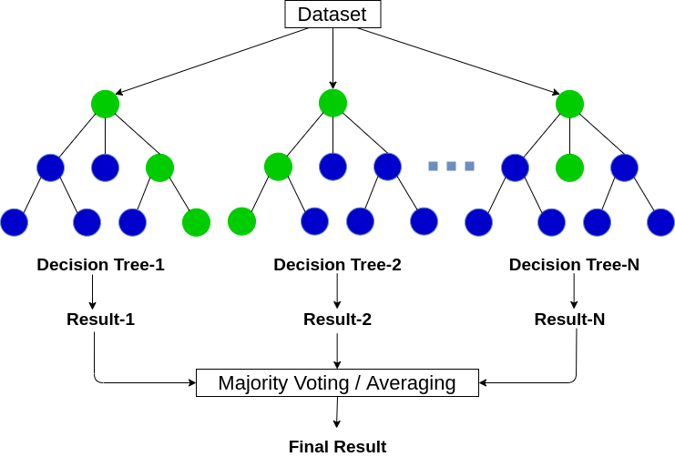

**Fig4:** Random Forest

**Entropy:** Entropy is the measurement of disorder or impurities in the information processed in machine learning. It determines how a decision tree chooses to split data.

S: Case set

n: Number of S partition

Pi: Probability obtained from the total (Yes / No) divided by the total case

**Applying Random Forest:**

For this dataset we got the accuracy upto 88% by using random forest algorithm.

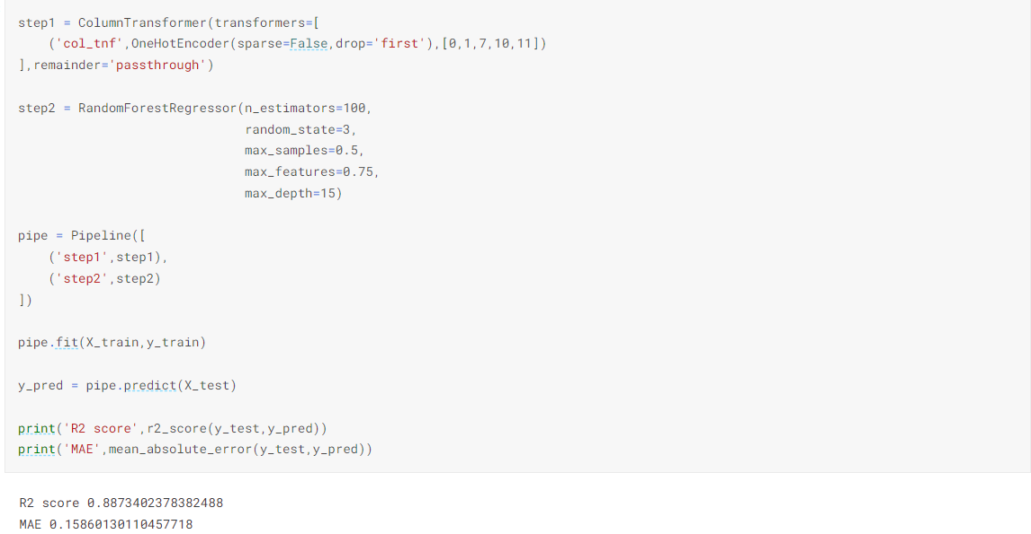

**Applying Decision Tree**

For this dataset we got the accuracy upto 84% by using Decision making algorithm.

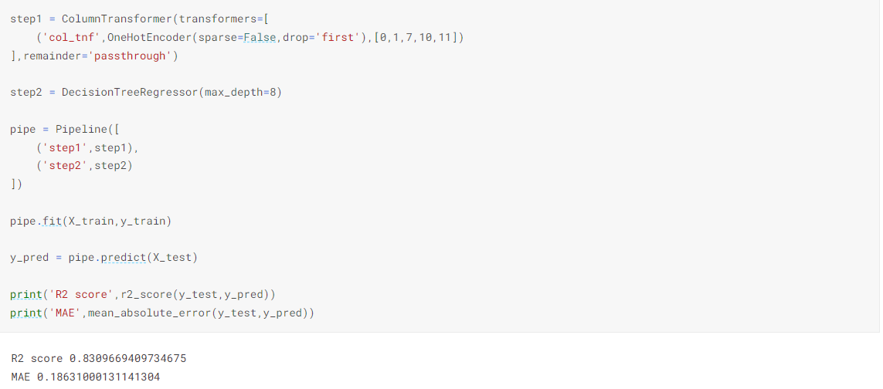

**Conclusion:**

The data which we use in this analysis have taken from the Kaggle, which are based on the real world pricing. In this analysis we had done data cleaning, exploratory data analysis and data visualization. We here by conclude that this laptop price prediction can be give the 88% accurately work by doing the classification using random forest which is a machine learning technique.

**References:**

1. Aminah Md Yusof and Ismail Syuhaida, "Multiple Regressions in Analyzing House Price Variations", IBIMA Publishing Communications of the IBIMA, vol. 2012, pp. 9, 2012.

2. M. A. Babyak, "What you see may not be what you get: A brief nontechnical introduction to overfitting regression-type models", Psychosomatic Medicine, vol. 66, no. 3, pp. 411-421.

3. Atharva shoogles, Priyanka chair, Akshata gaud and Jinal Jain, "House Price Forecasting using Data Mining Techniques International Journal of Advanced Research in Computer and Communication Engineering ISO 3297:2007 Certified", vol. 6, no. 12, December 2017.

4. Mehtab, S., Sen, J.: A time series analysis-based stock price prediction using machine learning and deep learning models, 1–46 (2020).